PRICE SCHEDULE

LOT 1 | DESCRIPTION | UOM | QTY | UNIT PRICE GH¢ | Total Price GH¢ | Total inland price GH¢ | TOTAL  CIP GH¢ | Incidental Ser. GH¢ | Total Tender Price GH¢
 | {{titleUpper}}
- {{#lineItems}}{{nums}} | {{description}} | {{uom}} | {{qty}} | {{unitPrice}} | {{totalPrice}} | NIL | {{totalPrice}} | NIL | {{totalPrice}}{{/lineItems}}
GRAND TOTAL: GH¢ {{grandTotal}}

TOTAL AMOUNT: {{grandTotalWords}}
VALIDITY: {{validityTerms}}
DELIVERY: {{deliveryTerms}}
PAYMENT: {{paymentTerms}}
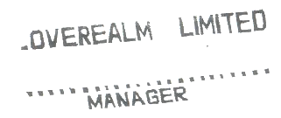
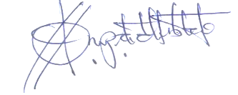
SIGNATURE: …………………………….

